**ASSIGNMENT 9.2**

**Twitter Data Stream with FLUME.**

Installed flume via given method IN **UBUNTU** .

**flume.conf**

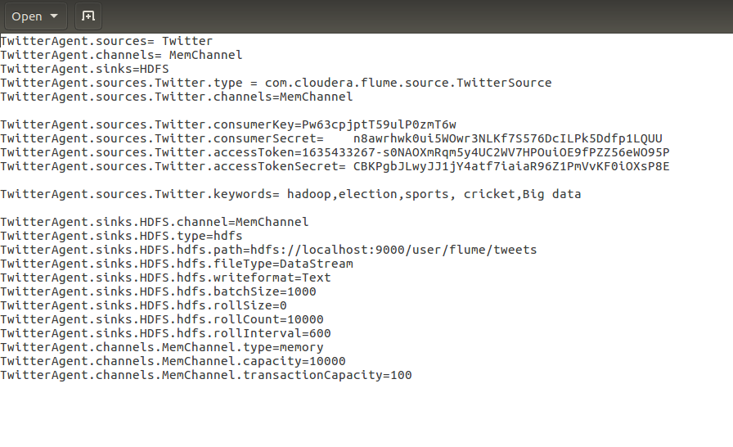

**twitter app create**.

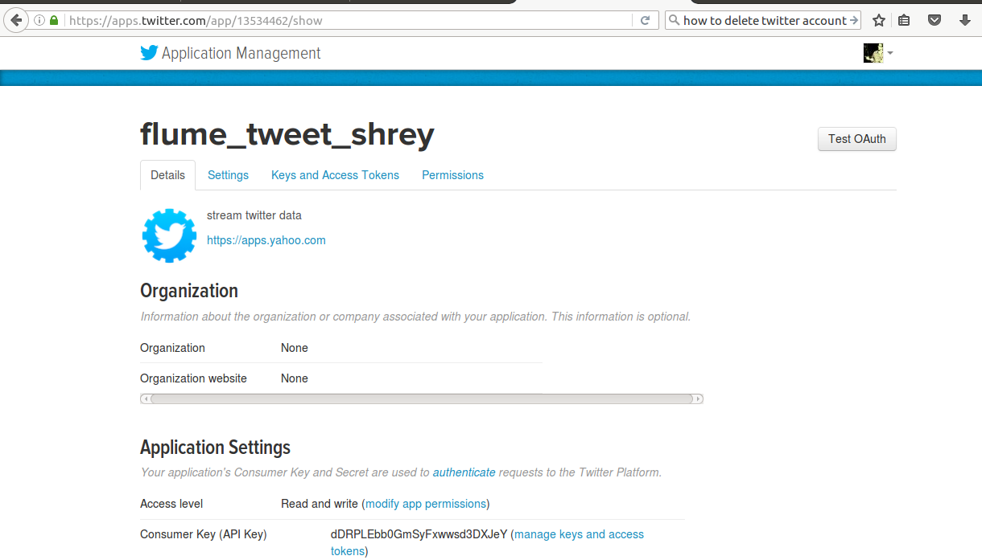

Run flume agent :

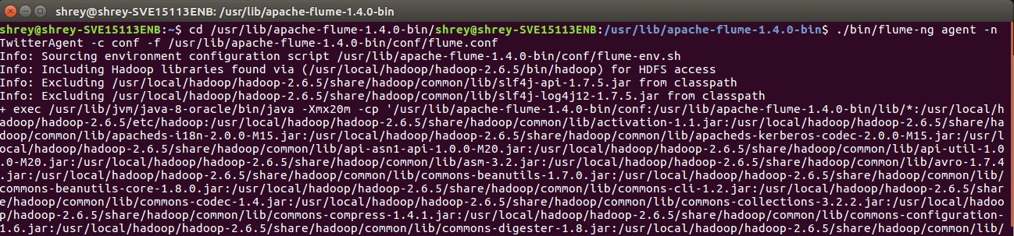

List on HDFS browser view:

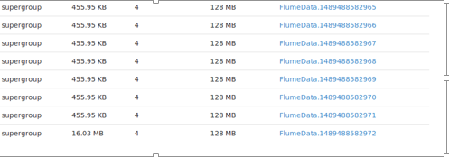

On opening the FlumeData file we can see that DATA STREAMING has begun and the

streaming is stopped by pressing (CTRL + C).

FlumeData file on HDFS using **cat** command:

